

**SYNOPSIS HTML**

**K19SJ**

|  |  |  |  |
| --- | --- | --- | --- |
| **S.no** | **Registration no.** | **Name** | **Roll no.** |
| 1. | 11904533 | Aditya Tiwari | 31 |
| 2. | 11902474 | Yeldhurthi Manas | 32 |
| 3. | 11902247 | Astha Singh | 10 |
| 4. | 11902305 | Kunhimma Sharoon | 33 |

**INTRODUCTION**

**Websites:**

A website is a group of web pages that have information in the various pages that contain similar subject materials. For instance, the web site would have a name (subject) such as GoodFords.com and have several pages related to good Ford vehicles. The website has a main web page commonly called the Homepage (index.html or default.html). The site's address will display the homepage and you can click on hyperlinks to go to other pages on the website.

A webpage is a text page written in a form of HTML (hyper text markup language) that contains text, links or tags that will display graphics, audio, video, downloadable files and of course other web pages.

**Marketing website:**

Every successful marketer has a web presence including a business domain name hosted at a reputable hosting company. As a matter of fact, most marketers have several domain names for the many different companies that they are actively marketing. Web marketing also referred to as online marketing has created now an important atmosphere to market the offerings of companies through the web and its applications. Internet marketing ties together the creative and technical aspects of the Internet, including design, development, advertising and sales. Internet marketing also refers to the placement of media along many different stages of the customer engagement cycle through search engine marketing (SEM), search engine optimization (SEO), banner ads on specific websites, email marketing, mobile advertising, and Web strategies.

**OBJECTIVE**

There are many objectives for marketing websites like:

* *Building or Introducing a brand:*

Internet marketing objectives often include building a brand. This means not only establishing your logo and company name in the minds of consumers, but also what your company stands for well-known brands are typically trusted more by customers, especially when paired with positive associations. The Internet is a great tool for building that trust, because it has a wide reach and allows you to directly connect with individuals.

* *Increase revenue:*

The primary goal of any marketing strategy is ultimately to increase revenue, and Internet marketing is no exception. Thankfully, the Internet provides plenty of opportunities for every business to improve their bottom line. By combining search engine optimization, or [SEO](https://www.webfx.com/SEO-Pricing.html), with [pay-per-click ads](https://www.webfx.com/ppc-management-services.html), or PPC, your company can improve the chances that potential customers find online. And with strategies like content marketing and [social media marketing](https://www.webfx.com/Social-Media-Pricing.html), we can position yourself as an expert in your field who also cares about the clients.

* *Manage Online Reputation:*

In an age when anyone with a computer or smartphone can post their opinions about companies, products, and services for the whole world to see, it’s important for businesses to maintain a solid online reputation. This means monitoring your company’s name, done maintaining social profiles, and responding to bad accordingly. One bad review doesn’t mean that your company’s reputation is shot, but one bad reaction to a bad review might. The way you publicly [respond to customer complaints](https://www.webfx.com/blog/marketing/respond-negative-reviews/) will show them (and all other current and potential customers) how much you care about.

**SYSTEM DESCRIPTION**

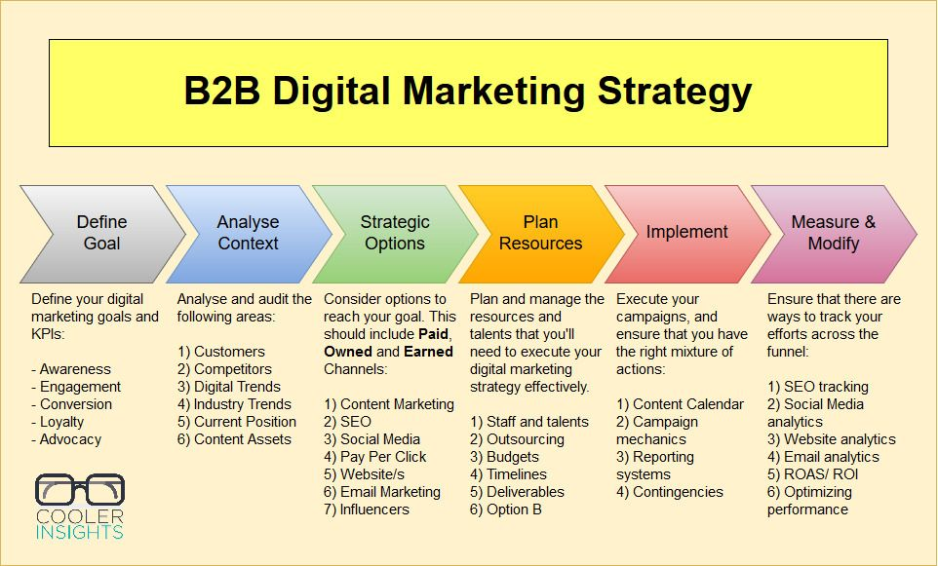

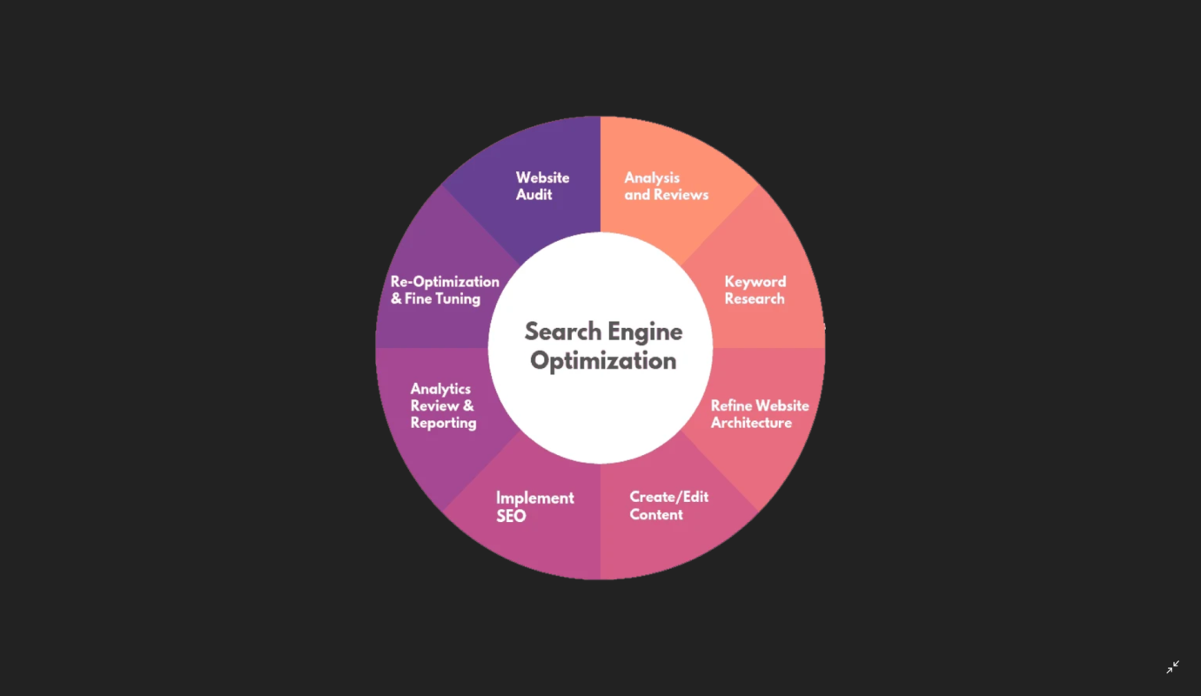

Search engine pattern for marketing websites (SEO companies 2020)

**DMR(BLUE PRINT)**



**Marketing website pattern**

**PREPARATION OF MARKETING WEBSITE**

We are preparing the marketing website by using HTML and CSS. Me and my group members have divided the work by writing the synopsis, designing the HTML by group discussion and also writing of final report.

**CONCLUSION**

The conclusion of digital marketing has now become a hot topic for discussion. Modern technology has changed a lot. Besides the growth of modern technology, the technique of businesses has also changed. In this regard, digital marketing comes to take the leading position.

**Direct advertising:** Through digital marketing, you can aware of your customers about your products. If you take a good advertising strategy and promotional tools, it can help you to perform well in the highly competitive market.

**Easy consumer reach:** If your main aim is to target a large sum of people, then digital marketing is a good way to communicate. Social media marketing has revolutionized the marketing activities. There are so many social media platforms. They are on Facebook, Twitter, Whatsapp, We chat, Skype, Google+, Blogs, Instagram, YouTube etc.

**REFERENCES**

* <https://en.wikipedia.org/wiki/Digital_marketing_system>
* <https://www.uniassignment.com/essay-samples/marketing/web-marketing-marketing.php>
* <https://www.webfx.com/internet-marketing/internet-marketing-objectives.html>